For Immediate Release

“Readers’ Favorite is proud to announce that "Ares" by Herefordshire Indie Author, K.A. Finn, is a Silver Medal Winner in the Fiction - Science Fiction category in our 2016 International Book Award Contest.”
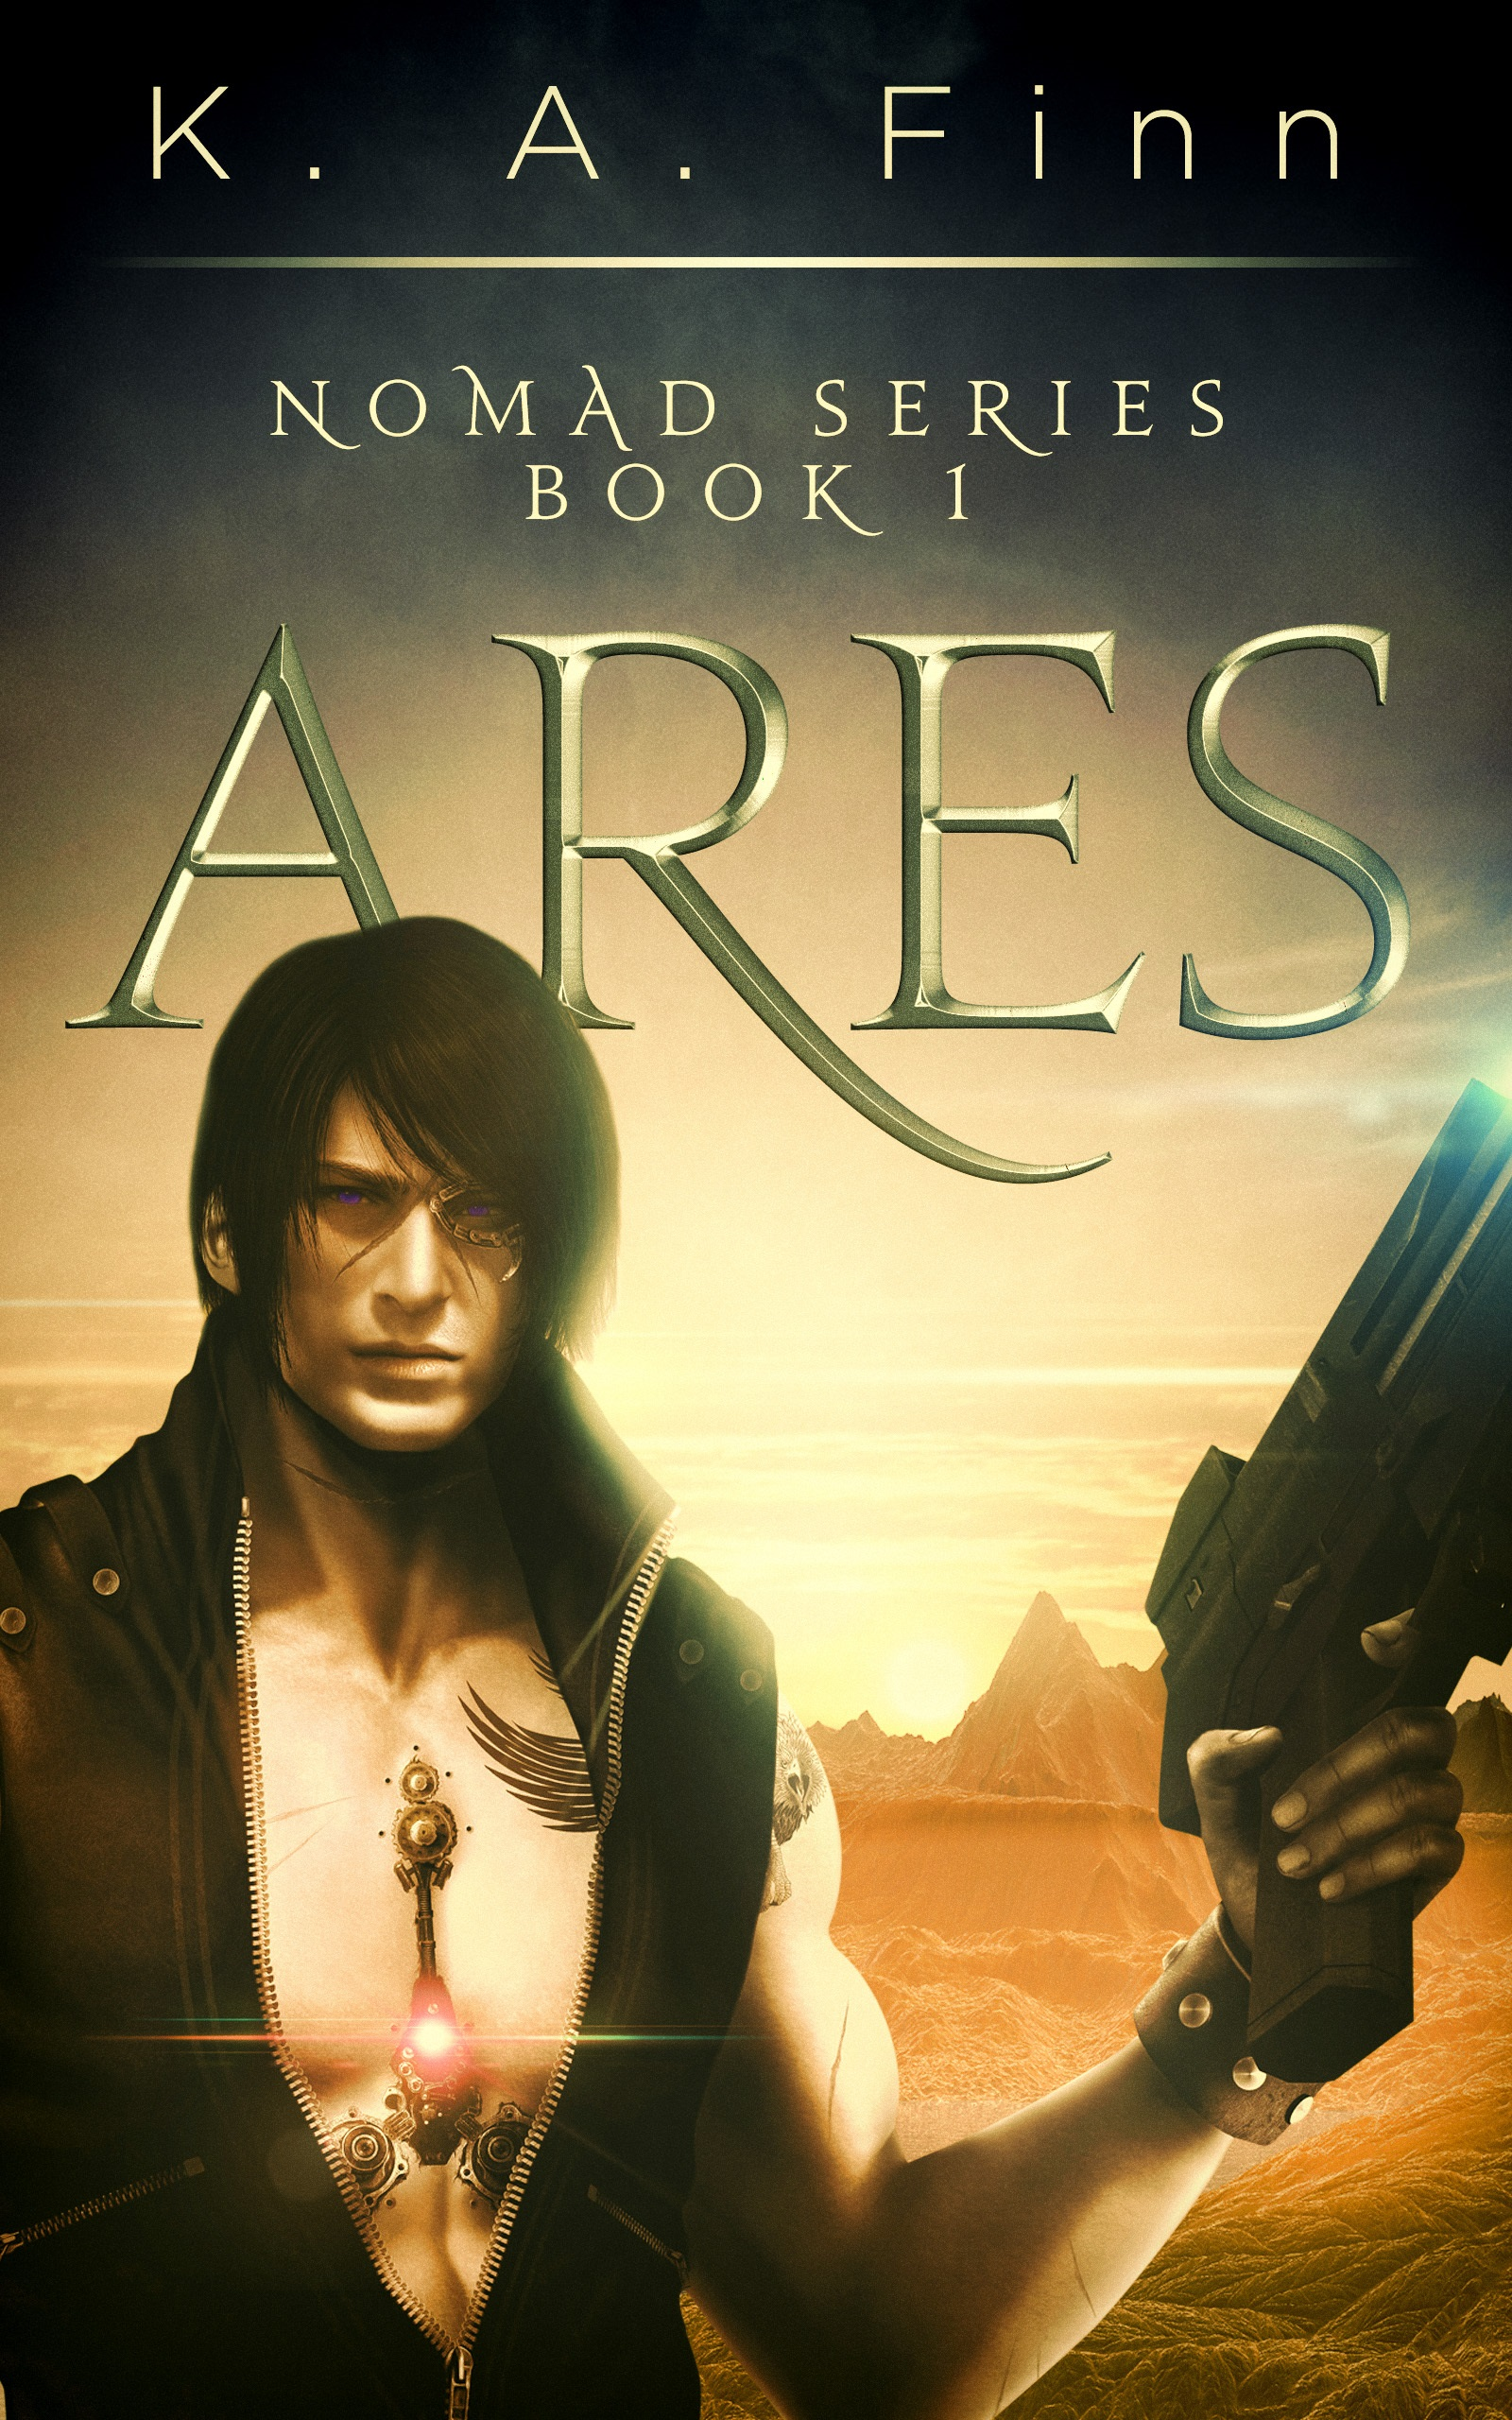
Herefordshire, UK (6th September 2016) - Reader's Favorite recognizes “Ares” in its 2016 international book award contest. The 2016 Readers' Favorite International Book Award Contest featured thousands of contestants from over a dozen countries.

Readers' Favorite has become the fastest growing book review and award contest site on the Internet. They have earned the respect of renowned publishers like Random House, Simon & Schuster, and Harper Collins, and have received the “Best Websites for Authors” and “Honoring Excellence” awards from the Association of Independent Authors. They are also fully accredited by the BBB (A+ rating), which is a rarity among Book Review and Book Award Contest companies.

In addition to reviewing for some of the biggest names in the literary industry, as well as the first time independent author, they host a respected award contest which features entries from new authors to NYT best-sellers, as well as celebrities like Jim Carrey and Henry Winkler.

Ares – Nomad Series Book 1
Gryffin was the sole survivor of The Foundation's experimental project to transform human children into hybrid cyborgs - half human, half machine. The program failed and he was sent on a one way trip into The Outer Sector where he was left for dead. He has survived for twenty years by suppressing his human emotions and embracing his machine side. Now they want their creation back and this time they have no intention of letting him go

The first book in the Nomad Series, Ares is packed full of pulsating action, romance and electrifying decisions. The book is masterfully written and is a fantastic read from start to finish. With its engaging, action packed and emotional plot, Ares definitely has the brilliance and makings of a dramatic TV series.
Like every first time author, K.A. Finn is excited about her new book. When asked about the inspiration behind the spellbinding novel, she said: "I've been an avid sci-fi fan for most of my life and used to race home from school with my sister to watch Star Trek. My main character popped into my head one day and grew and developed into the character he is today. Along the way he brought the other characters in and they've all stuck around."
Since its March 21 2015 release, Ares has amassed a number of impressive reviews, awards, and high ratings.
- 2015 New Apple Science Fiction Gold Medal Winner
- “LOVED IT!! I could not put it down with lots of plot twist and engaging characters - a fantastic read!” Amazon reviewer
- “A great sci-fi that kept me entertained. This is a novel that makes you want to read more. The story unfolds in the best possible manner and the characters are well developed. It was a joy to read. Kudos to K.A. Finn for writing such a great novel’ Readers' Favorite reviewer
K.A. Finn grew up on the South East coast of Ireland before moving to a rural smallholding in Hereford. After studying media production, KA Finn enjoyed a working career in veterinary nursing, financial services and, most recently, in the electrical and engineering industries. KA Finn passion for writing science fiction integrates with a busy family life, freelance proofreading and agricultural interests.
Ares and Nemesis (Book 2 in the Nomad Series) are available on Amazon and Smashwords in eBook and paperback format, and on Audible and iTunes in audiobook format.
Perses, (Book 3 in the Nomad Series), is due for release in 2017 in ebook, paperback, and audiobook format with the forth book, Cronus, following later in 2017 or early 2018

Learn more about K.A. Finn and the Nomad Series books at
http://www.kafinn.com/
https://www.facebook.com/kafinnNOMAD/
https://readersfavorite.com/book-review/ares
https://www.amazon.co.uk/-/e/B00VDGHZF8

K.A. Finn
info@kafinn.com

