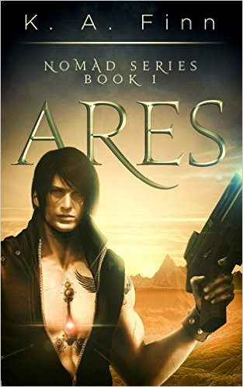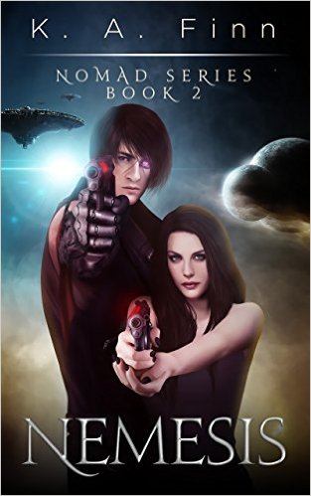

Nomad Series: Intense, Cinematic New Sci-Fi Series Exposes Raw, Epic Struggle of Emotionally-Torn Cyborg

Celebrated by critics for its “epic space battles” and “unique, fast paced, story”, the first two volumes in K A Finn’s ‘Nomad’ series take readers deep into the life of a cyborg, the sole survivor of a political dictatorship’s experimental project, who is left for dead in an unfamiliar place. However, colonization is on the horizon, he falls in love with the most unlikely of acquaintances and what ensues is leaving readers gripped to every page…

Contact:
K A Finn
Email: info@kafinn.com

FOR IMMEDIATE RELEASE

United Kingdom – Astonishingly, ‘The Nomad Series’ is K A Finn’s first foray into the literary world, but readers would never know it. After all, creating science fiction worlds that feel as real as the earth that surrounds us is no easy feat. However, under the skilled hands of a writer like Finn, it appears seamless.

Taking her fans into the epic battle between man and machine is what Finn lives for as a writer, and she’s certainly achieved it with gusto in ‘Ares’ and ‘Nemesis’. Think it would be impossible to fall in love with a cyborg? Think again.

Oh yes, nobody said it would exactly be easy…

Synopses:

‘Ares’ - He wasn't expected to survive — no one else did — and for twenty years, he has managed to stay off their radar. Until now. Until her…
Gryffin was the sole survivor of The Foundation’s experimental project to transform human children into hybrid cyborgs – half human, half machine. The program failed and he was sent on a one way trip into The Outer Sector where he was left for dead. He has survived for twenty years by suppressing his human emotions and embracing his machine side.
Officer Terra Rush believes in her duty to the Foundation. The Sector needs to be prepared for colonization, and nothing can stop her from doing her job…except him. When Gryffin saves her from an attack, Terra uncovers a terrible secret. The Foundation has been lying to her…and maybe they still are.
They have labelled Gryffin a killing machine, yet he acts more human than many of The Foundation’s leaders. He has awakened intense feelings in Terra that throw her loyalties into question, and even though he pushes her away, she is determined to find out the truth about the cyborg program.
Gryffin refuses to be a mindless soldier, yet escaping The Foundation’s control and stopping the colonization of his home will require Terra’s help. Can Gryffin overcome the machine inside and trust her? Or will getting in touch with his human emotions destroy him once and for all?

‘Nemesis’ - A part of her died when she lost him…
Commander Terra Rush has spent the last eight months mourning Gryffin, believing he died when his ship crashed. When he returns to her, broken and scarred from months of torture at the hands of the Foundation, it feels like a miracle. At first.
His unpredictable mechanical side, reawakened by the brutality he endured as a prisoner, threatens to destroy him. He’s lost the trust of the colonists. Has he lost part of himself as well?
Her need to protect her ravaged heart puts distance between them when they need to depend on each other the most. If the colonists are to survive, they need Gryffin to reunite the Nomad and stand with them…and he needs Terra’s help to do so. But time and tragedy have changed them both so much. Can they find their way back to each other before everything they know is destroyed?

“We live in a world where science fiction runs rampant as one of, if not the most popular literary genre. But there’s just one problem, most books are playing into the clichés of spaceships zipping across the galaxy and the like. It was time for something different, for cyborgs to make their resurgence!” explains Finn. “But, at the same time, my goal was to create a story so engaging and vivid that Gryffin and his human qualities start to blur the lines between fact and fiction in the minds of readers.”

Continuing, “Initial feedback has been overwhelmingly positive, so much so that I’ve already commenced planning and writing for the third volume. Get started on the series now, as it’s about to kick off big time!”

Readers agree, leaving many positive reviews. For example, Sammi comments, “Ares is the first book of a series that's new to me called Nomad, and it's an intriguing and different take on a traditional science fiction. It's also a bang-up beginning. I was fully charmed by this book; the author writes creative, easy to read and exciting fiction. In the same vein as the recently popular dystopian science fiction, Ares depicts a world that's the result of a morally questionable experiment and the aftermath that creates for the major players herein Gryffin and Terra .I definitely enjoyed this book and I think this concept would make for a great TV show as well as a book. Five stars - highly recommended.”

‘Ares’ is available now: http://amzn.to/1OWkmTv (Amazon US) / http://amzn.to/1HXJqKt (Amazon UK) / http://adbl.co/1Q5ExBY (audible)

‘Nemesis’ is due for release in January of 2016. Pre-orders are currently being accepted:
http://amzn.to/1Y0JGiV (Amazon US) / http://amzn.to/1NYR49U (Amazon UK)

About the Author:

K.A. Finn grew up on the South East coast of Ireland before moving to a rural smallholding on the Welsh marches. After studying media production, KA Finn enjoyed a working career in veterinary nursing, financial services and, most recently, in the electrical and engineering industries.
Opportunity offered KA Finn the chance to write and publish the first book of the Nomad Series, Ares; a concept that had been written and re-written (and re-written again) for more than 20 years, evolving, and developing with each year. KA Finns’ writing incorporates science fiction with elements from past and present, and hints of Celtic mythology.

KA Finn passion for writing science fiction integrates with a busy family life, freelance proofreading and agricultural interests.

Any free time is spent reading Stephen Leather, Andy McNab, J.R. Ward, Lee Child, James Rollins, and J.D. Robb.

